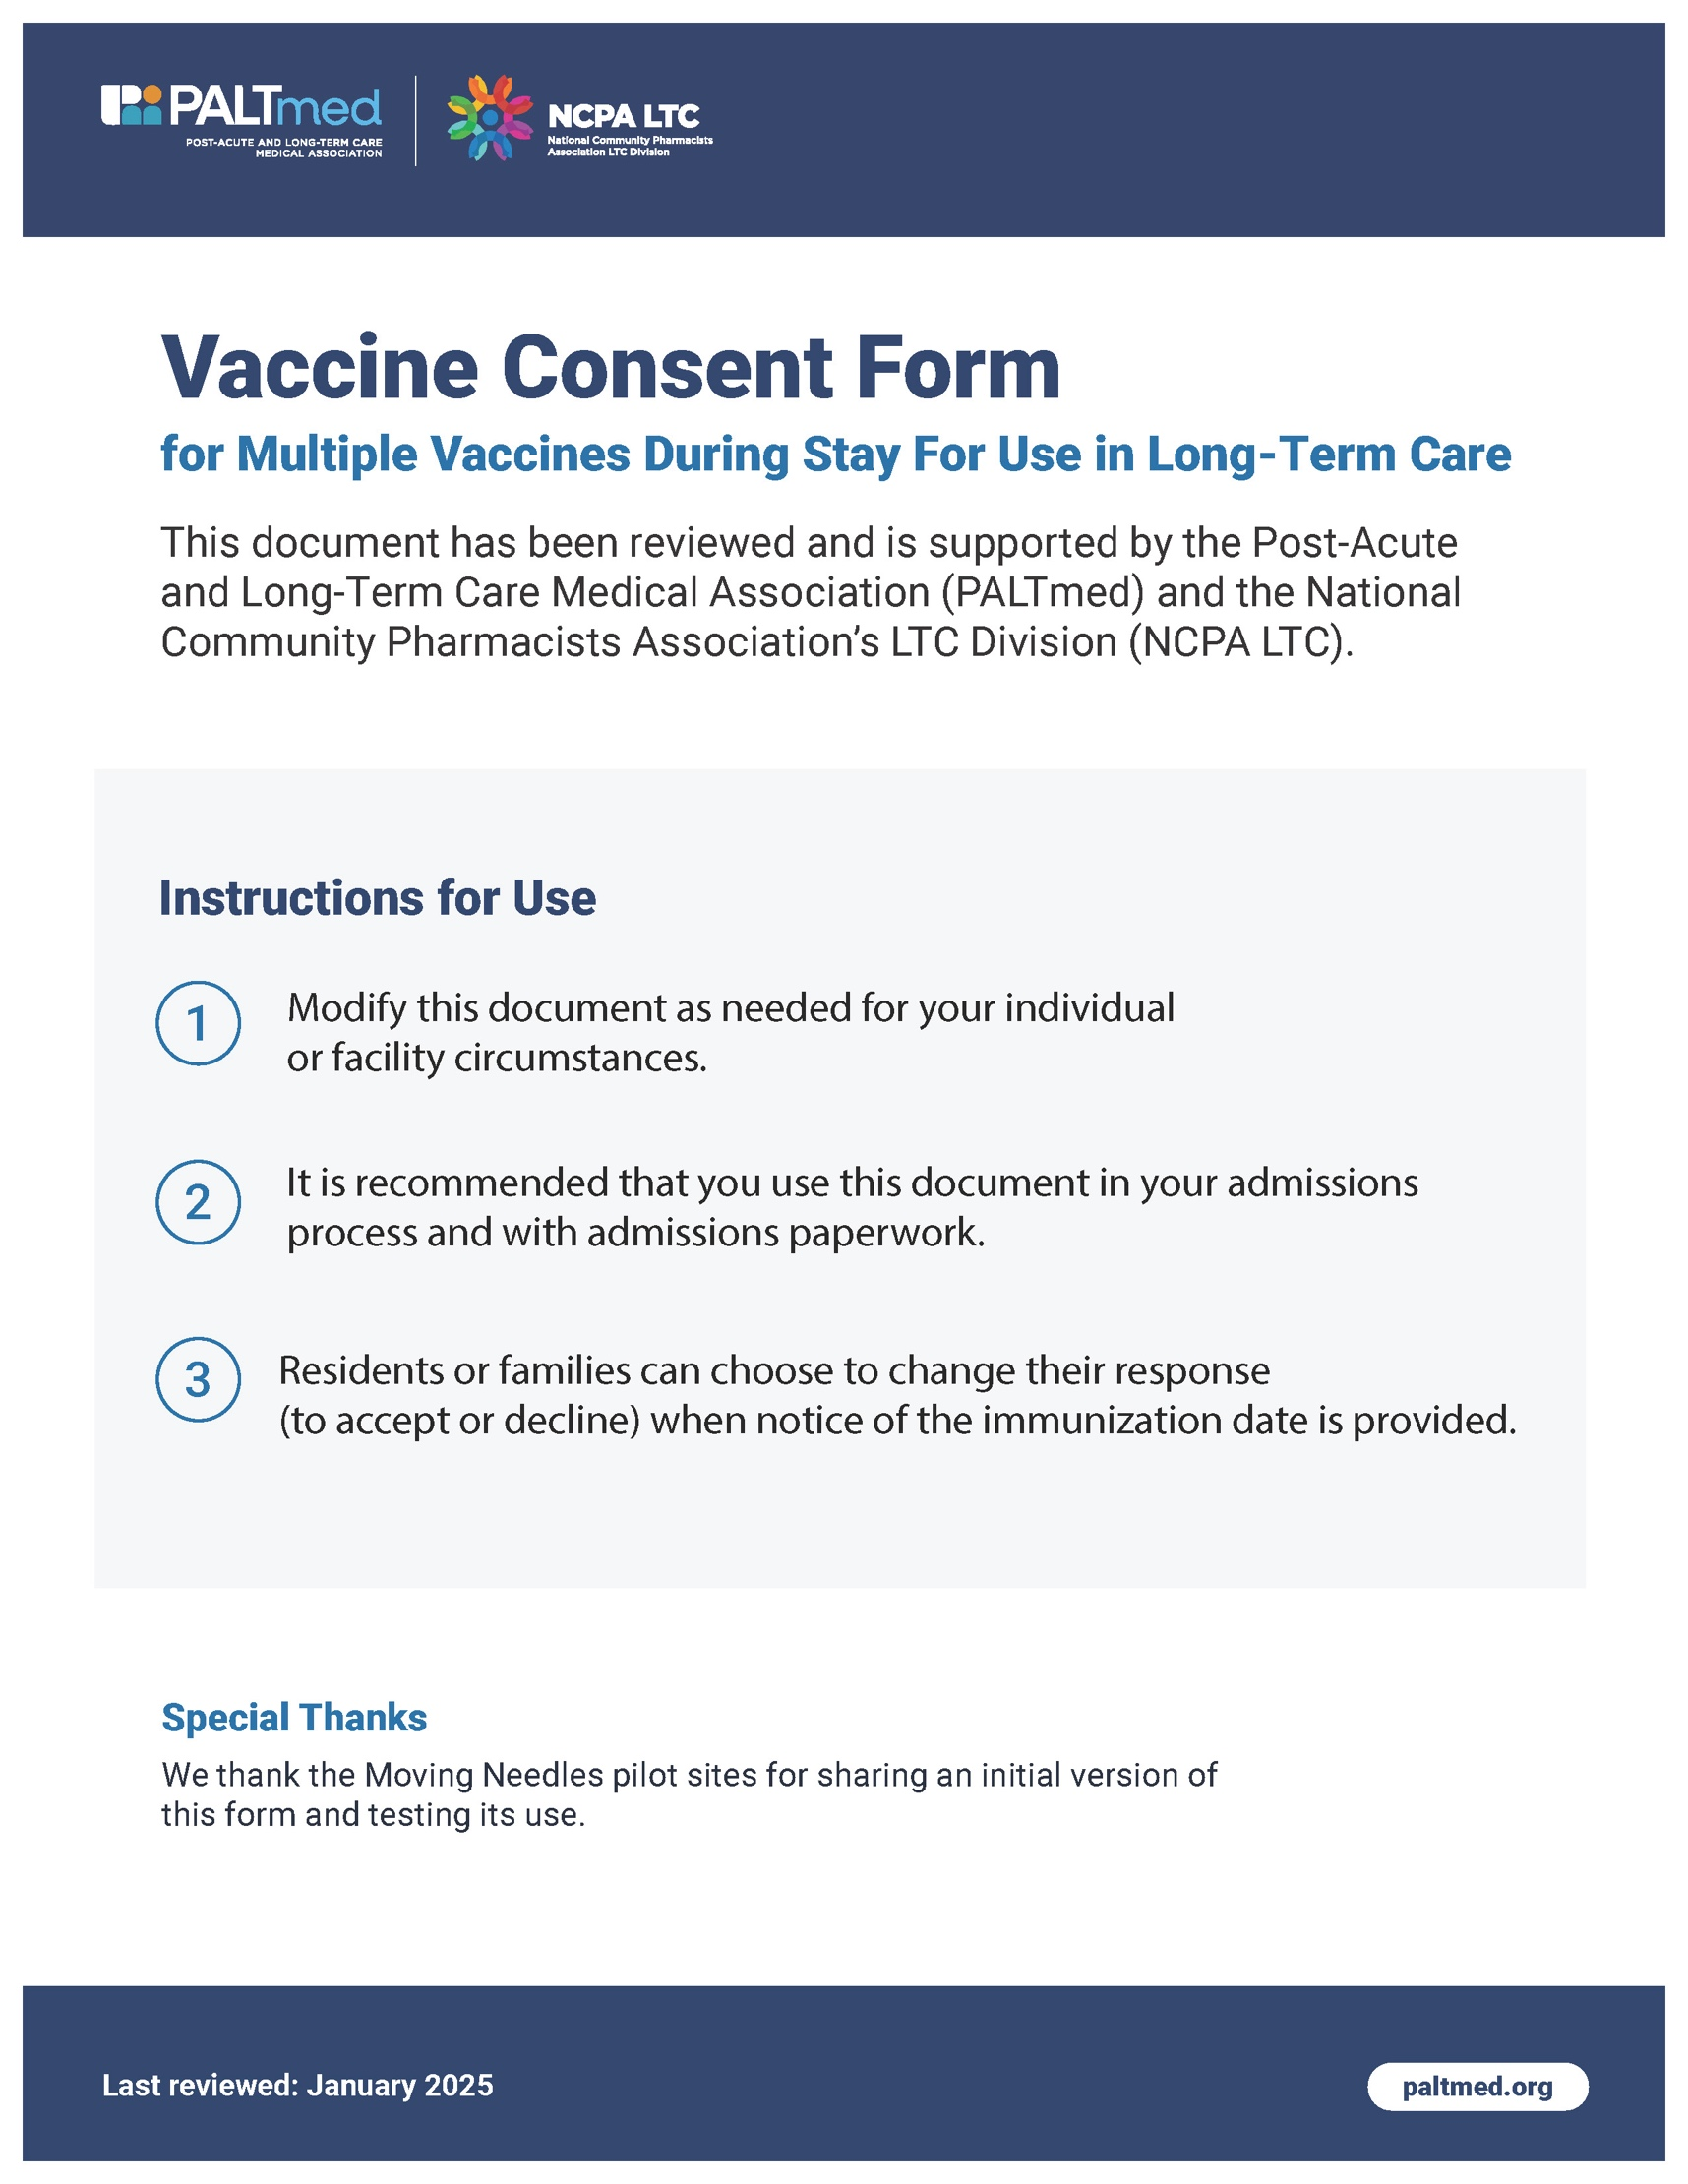Vaccine Consent Form - Multiple Vaccines
I, the undersigned, have received information about the risk and benefits of the vaccines listed below and have received a copy of the Vaccine Information Statement.

I have had the opportunity to ask questions and have received answers to my satisfaction. I understand the vaccination process and freely consent to such process.

I understand that I will be screened for eligibility prior to receiving any vaccine dose based on the recommended vaccine schedule by the National Advisory Committee for Immunization Practices (ACIP).

I understand that I may change my mind about vaccination at any time prior to receiving the vaccine(s).

I understand that this consent form is good for 3 years. It will be reviewed and offered for renewal every 3 years or as updates may require.
I certify that I am (a) the patient/resident, (b) the legal guardian of the patient/representative or (c) representative of the long-term care facility and based upon observation or at my capacity, have the sufficient knowledge to answer the screening questions.

I authorize release of any medical/other information with respect to this vaccine to my healthcare providers, Medicare, Medicaid or any other 3rd party payer as needed and request payment for authorized benefits to be made on my behalf to the facility or pharmacy.

I consent to the vaccines selected below as indicated by circling Yes. My signature also authorizes entry of the vaccination(s) into the State Immunization Registry.

Vaccine | Consent
Influenza | Yes No
COVID-19 | Yes No
Pneumococcal (PCV15, PCV20, PCV21; PPSV23) | Yes No
Respiratory Syncytial Virus (RSV) | Yes No
Tdap | Yes No
Shingles | Yes No
Other Vaccines recommended by ACIP (list here): | Yes No

Signature of Resident or Legal Representative Date/Time

Print Name of Resident or Legal Representative

If Legal Representative, state relationship to Resident
**If Legal Representative, please ensure receipt of a copy of the Healthcare Power of Attorney, Advance Directive, Letters of Guardianship, or other documents that authorize Resident Representative to execute this consent.

Legal Name (including maiden name) Birthday

Medical Record Number Admission Date

Name of Physician
Screening Checklist
Are you sick today? | Yes No Don’t Know
Have you ever had a serious reaction after receiving a vaccine? | Yes No Don’t Know
Do you have any of the following: a long-term health problem with heart, lung, kidney, or metabolic disease (eg, diabetes), asthma, a blood disorder, no spleen, a cochlear implant, or a spinal fluid leak? Are you on long-term aspirin therapy? | Yes No Don’t Know
In the past 6 months, have you taken medications that affect your immune system, such as prednisone, other steroids, or anticancer drugs; drugs for the treatment of rheumatoid arthritis, Crohn’s disease, or psoriasis; or have you had radiation treatments? | Yes No Don’t Know
Have you had a seizure or a brain or other nervous system problem? | Yes No Don’t Know
Have you ever been diagnosed with a heart condition (myocarditis or pericarditis) or have you had Multisystem Inflammatory Syndrome (MIS-A or MIS-C) after an infection with the virus that causes COVID-19? | Yes No Don’t Know
In the past year, have you received immune (gamma) globulin, blood/blood products, or an antiviral drug? | Yes No Don’t Know
Have you received any vaccines in the last 4 weeks? | Yes No Don’t Know
Have you ever felt dizzy or faint before, during, or after a shot? | Yes No Don’t Know

